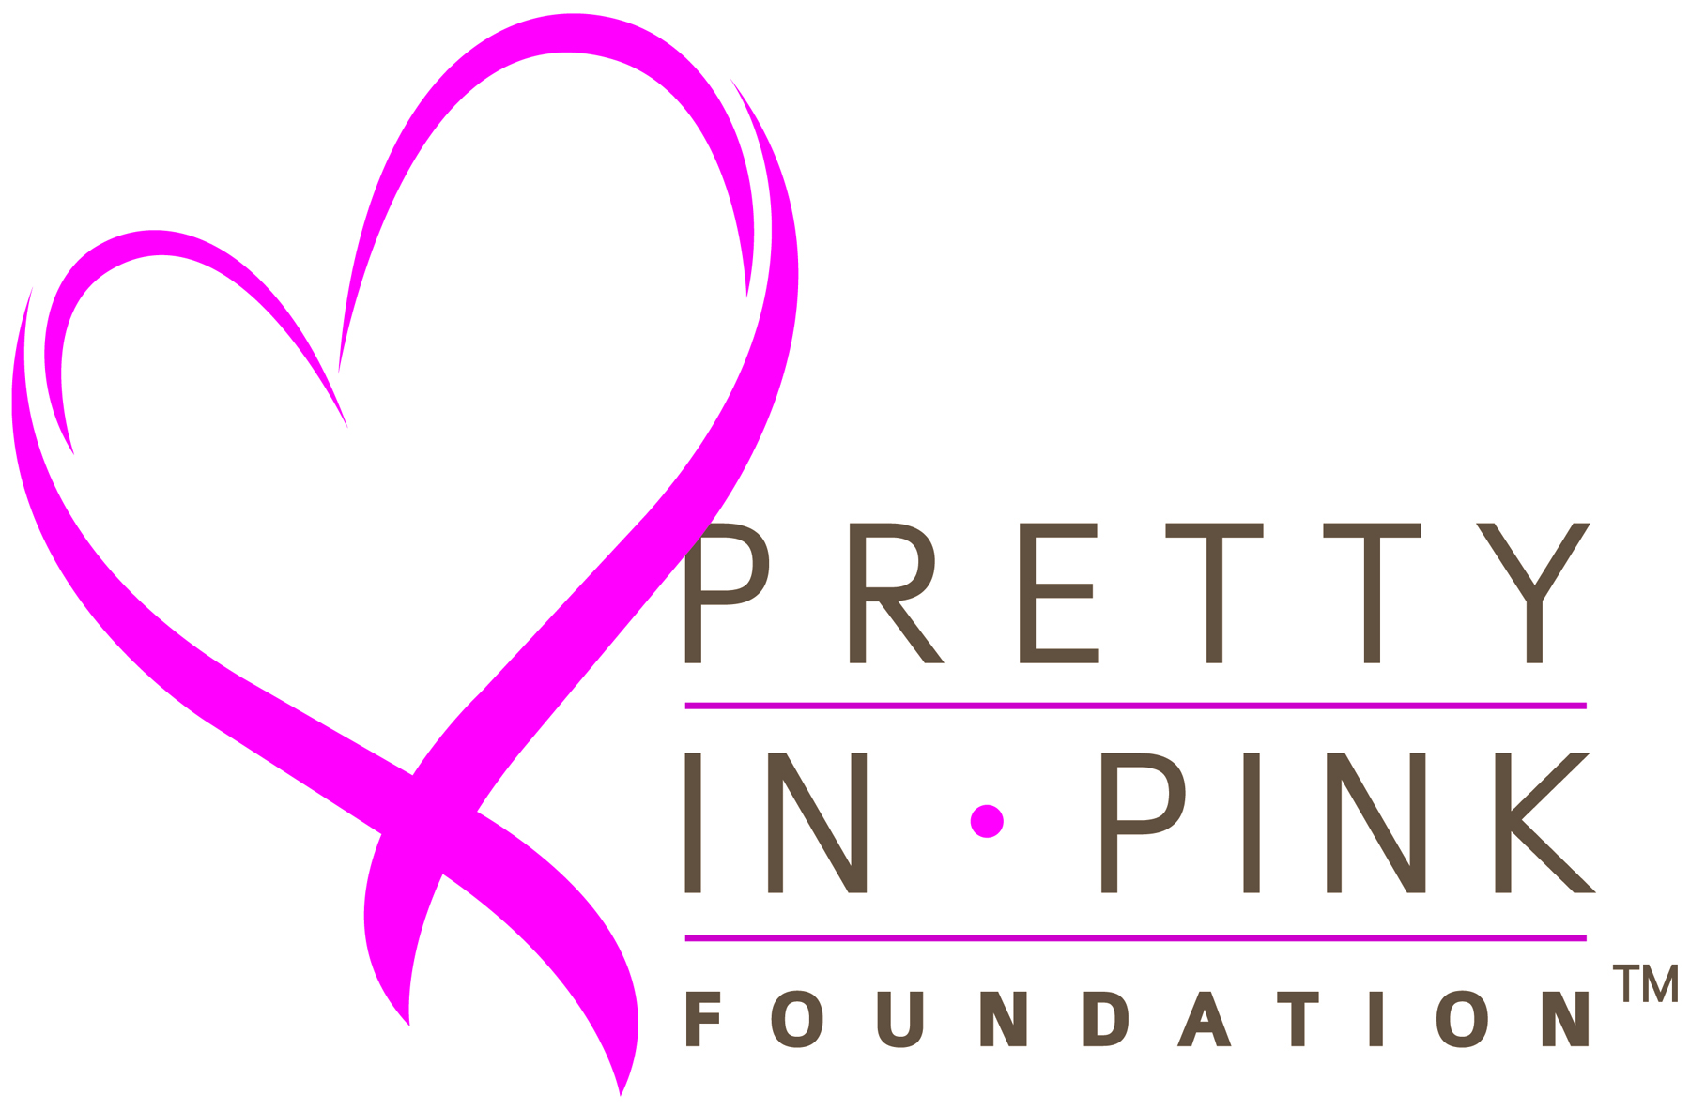 Patient Treatment Assistance
Guidelines & Requirement
Applicant Requirements
- North Carolina resident who has been diagnosed with breast cancer and is in any phase of active treatment
- Must be a US citizen
- Financial assistance is only provided from time of application receipt and approval
- Household income eligibility:

Family Size | Maximum Household Income | Family Size | Maximum Household Income
1 | $30,150 | 5 | $71,950
2 | $40,600 | 6 | $82,400
3 | $51,050 | 7 | $92,850
4 | $61,500 | 8 | $103,300

Instructions:
- Complete and submit the Financial Assistance Request Form-Preliminary Request by mail or by fax
- Have your referring physician that is providing treatment:
    - Complete the Medical Referral Form
    - Attach your pathology report

The Medical Referral Form must be signed by a referring and treating physician, such as Surgeon, Oncologist, or Radiologist. Your social worker or patient navigator should be able to facilitate getting this form completed, and signed by the doctor. You can submit the Medical Referral Form and Pathology Report with your Financial Assistance Request Form; Or you can have your physician’s office send it directly to us by mail or fax.

Please note that the types of expenses the Foundation considers are associated with:
Surgical Consultations Surgery (excluding reconstruction) Chemotherapy Administration (excluding medications)
Radiation Therapy Physician office co-payments COBRA Premiums

After your Financial Assistance Request Form is preliminarily screened and you meet the screening eligibility, our Patient Resource Coordinator will contact to request the final documentation to complete your full application. If you wish, you may go ahead and submit these documents with your initial Financial Assistance Request Form.

These will include:
- Last 2 pay stubs or proof of unemployment. If your income is solely Social Security or Social Security Disability Income, then a copy of Social Security or Social Security Disability Income statement or letter.
- Most recent federal tax return or Schedule C if self-employed
- Copy of a utility bill
- Copy of driver’s license or alternate ID
- If you are insured: copy of current Insurance, Medicare or Medicaid card (front and back)
- If your uninsured: copy of Medicaid and/or social security, disability rejection letters

Notes
- Requests cannot be submitted for Medical Advisory Committee review until all required documents are received
- Approval may take up to 30 days
- Foundation grants assistance on a first-come, first-served basis to the extent that funding is available
- Medical Advisory Committee sets eligibility criteria and has final determination in all cases and reserves right to change program in its entirety or with respect to any applicant at any time with or without notice

Address for mailing forms and documents to: Questions:
Pretty In Pink Foundation Telephone: 919-532-0532
6500 Creedmoor Road – Suite 106 Fax: 919-977-6759
Raleigh, NC 27613 info@prettyinpinkfoundation.org

Request received: _____________
PIPF Number: ______________

Pretty In Pink Foundation
Financial Assistance Request Form (Preliminary Request)

This preliminary request will be used to determine if applicant qualifies for completion of full application which will be submitted to
the Medical Advisory Committee.

Preliminary request may be mailed to: Questions/Submit by Fax:
Pretty In Pink Foundation – Attn: Patient Financial Request Call: 919-532-0532
6500 Creedmoor Road – Suite 106 Fax: 919-977-6759
Raleigh, NC 27613

Date of Application: ______________________
Applicant Name: ___________________________________________________________
(Last) (First) (MI)
DOB __________ Age _________ SSN#(last 4)____________________
Reason f Home Address: ______________________________________________ City: __________________________
County: ________________________ Zip: _____________ Email: _____________________________________
Ph Home Phone: ____________________ Work Phone: _____________________ Cell: _____________________
Referral: Hospital/ Clinic or Patient Navigator: _________________________ Phone: ___________________
Request for assistance: No Medical Insurance / Co-pay / COBRA / Co-insurance __________________
Where are you currently in your treatment? Surgery – Chemotherapy – Radiation – Other __________________

Insurance Information (please check all applicable)
1. Current Coverage: Medicaid ____ Medicare ____ Private health insurance ____ COBRA _____ Other__________
2. Insurance Provider: _____________________________ Co Pay(s): General ___________ / Specialty ____________
Insurance Monthly Premium _____________________ Deductible ________________ Deductible Met? Y N

3. Other Financial Assistance/ Charity Programs applied for:
Program __________________________________________________ Outcome __________________________
Program __________________________________________________ Outcome __________________________
Other assistance requested: Rent / Utilities / Phone /Transportation / Childcare / Food / Wig / Bra / Prosthetic unit(s)

Medical Information
Diagnosis: _____________________ Date of Diagnosis: _____________________
Treatment Plan: Surgery _____ Chemotherapy _____ Radiation Therapy ____ Other _____________

Financial Services Contacts:
Name: __________________________________ Hospital / Clinic: __________________________________
Phone: __________________________________ Fax: _________________________________________

Physician Care Team:
Surgeon: _____________________________________ Hospital / Clinic: __________________________________
Oncologist: ___________________________________ Hospital / Clinic: __________________________________
Radiologist: ___________________________________ Hospital / Clinic: __________________________________

Financial Information Patient Spouse
1. Total # in household _______ Children under 18 ______ Monthly Income $_________ Monthly Income $_________
2. Employed? Y N Last worked: _________________ PT _______ FT _______ Casual ________
Employer: ___________________________________________________________
Position/Title: ___________________________________________________________
If requesting assistance for COBRA: COBRA Monthly payment __________ COBRA approval date __________________

Income Information
Income Source | Monthly Amount |  | Monthly Expense | Monthly Amount
Total Household Income | $ |  | Rent / Insurance | $
Unemployment Compensation | $ |  | Food | $
Retirement Pension/ SSD/ SSI | $ |  | Childcare | $
VA Benefits | $ |  | Electricity / Heat | $
Worker’s Compensation | $ |  | Water /Sewer/ Garbage | $
Interest / Dividends | $ |  | Cable TV / Internet | $
Public Assistance | $ |  | Transportation | $
Other | $ |  | Medicine/Supplies | $
Assets |  |  | Liability
Stocks / Bonds/ Money Markets | $ |  | Home Mortgage | $
Rental Income | $ |  | Property Tax | $
Family Support | $ |  | Child Support | $
IRA / Other | $ |  | Credit Cards | $
Total Monthly Income | $ |  | Total Monthly Expenses | $

Release of Information & Authorization

I have read Pretty In Pink Patient Treatment Assistance Guidelines & Requirements and I declare that the information furnished on this application form is true and correct to the best of my knowledge.

All information is reviewed by members of the Pretty In Pink Foundation Patient Treatment Assistance Medical Advisory Committee and is confidential. I understand that all applications will be reviewed on a case-by-case basis and final determination will be made by Medical Advisory Committee of Pretty In Pink Foundation.

I understand that any elective procedures (cosmetic surgery/breast implants) are not eligible for financial assistance.

I will apply for assistance (Medicare, Medicaid, and other charity programs), which may be available for payment for my hospital charges. If you receive other assistance, please provide this information to the Pretty In Pink Foundation.

I understand my request for financial assistance may only be for eligible expenses (surgery, chemotherapy (less medications), and radiation) as by agreement of participating physician. Requests may also be considered for health insurance premiums and COBRA premiums in situations where coverage is threatened for continuation.

I also understand that if my preliminary application is accepted, I will provide all other items pertaining to request. I understand my submission of full application does not guarantee granting of funding.

______________________________________ ________ ______________________________
Applicant’s Signature Date
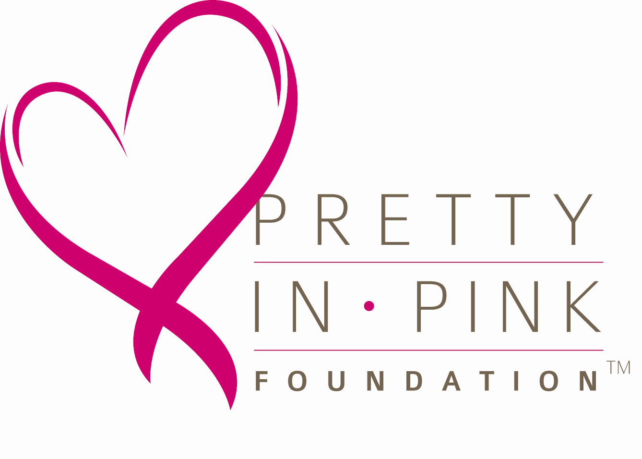 Medical Referral
(To be completed by Medical Health Professionals Only)
Fax to Pretty In Pink Foundation: 919-977-6759

Patient Name: _________________________________________________________________________________

Healthcare Professional:

Name of Practice/Clinic:

Please Attach Pathology Report:

Contact name to discuss financial request: __________________________________________________________

Phone: Fax:

Date of Diagnosis: Diagnosis Code: _________________

Current Treatment / Treatment Plan (may attach separate sheet as necessary)
Surgery_________________________________________________________________________________________
Chemotherapy___________________________________________________________________________________
Radiation Therapy________________________________________________________________________________
Please indicate if others services may be required: ____________________________________________________________________________________________

Please answer the following to help us review case as presented:
- Are you a Project Access Enrollee Site? Yes No
- Has patient applied for Medicaid/Medicare? Yes No
- Does your facility or health system offer financial assistance? Yes No
If yes, has patient completed application Yes No
- Does patient require additional support services? Yes No
(Support group, Navigation, accessories (wig, prosthesis, garments, etc) __________________________
- What services are you requesting Pretty In Pink to consider? ___________________________________
_____________________________________________________________________________________

Other physicians that will be participating in care:
Surgeon: ______________________________ Hospital / Clinic: ________________________________
Oncologist: ____________________________ Hospital / Clinic: ________________________________
Radiologist: ____________________________ Hospital / Clinic: ________________________________

Please write any additional information or comments you may have concerning the applicant receiving financial assistance from
Pretty in Pink Foundation and why you are referring this patient.

Name of Referring Physician:
Signature of Referring Physician: Date:

Date Received:
PIPF Number:

MEDICAL/HEALTH INFORMATION RELEASE & AUTHORIZATION

North Carolina and Federal law protect the privacy and confidentiality of an individual patient’s medical
records. In order for Pretty In Pink Foundation to access your medical information as part of its
financial assistance process, a Release & Authorization form must be executed for your health
care provider(s).

I authorize Pretty In Pink Foundation to request, use, and disclose certain health care and billing information regarding my breast cancer diagnosis, treatment, and medical bills from and to the following:

_____________________________________________________________________________________
(Name of health care provider)

_____________________________________________________________________________________
(Name of health care provider)

_____________________________________________________________________________________
(Name of health care provider)

Information will be used or disclosed for the following purposes: to assist the Foundation in determining my eligibility for financial assistance, and if awarded assistance to pay grant funds toward eligible medical bills. Pretty In Pink Foundation will not receive payment or other remuneration from a third party in exchange for using or disclosing health information, and will maintain privacy regarding personal health information.

This Release and Authorization shall expire twelve (12) months from its execution, if not revoked prior thereto. I have the right to revoke this authorization in writing except to the extent that the practice has acted in reliance upon this authorization. My written revocation must be submitted to the Pretty In Pink Foundation at 6500 Creedmoor Road, Suite 106, Raleigh NC, 27613 or emailed to info@prettyinpinkfoundation.org.

Print Name

______________ _________________
Date of Birth SSN (last 4 digits only)

_____________________
Signature of Patient Date

Name:
PIPF Number:

Your Story

The Pretty In Pink Foundation Board has no way of knowing you except through this application.
Please use this space to share your story or additional information, so that we might better understand your need for assistance.

___________________________________________________________________________________

___________________________________________________________________________________

___________________________________________________________________________________

___________________________________________________________________________________

___________________________________________________________________________________

___________________________________________________________________________________

___________________________________________________________________________________

___________________________________________________________________________________

___________________________________________________________________________________

___________________________________________________________________________________

___________________________________________________________________________________

___________________________________________________________________________________

___________________________________________________________________________________

___________________________________________________________________________________

___________________________________________________________________________________

___________________________________________________________________________________

___________________________________________________________________________________

___________________________________________________________________________________

___________________________________________________________________________________

